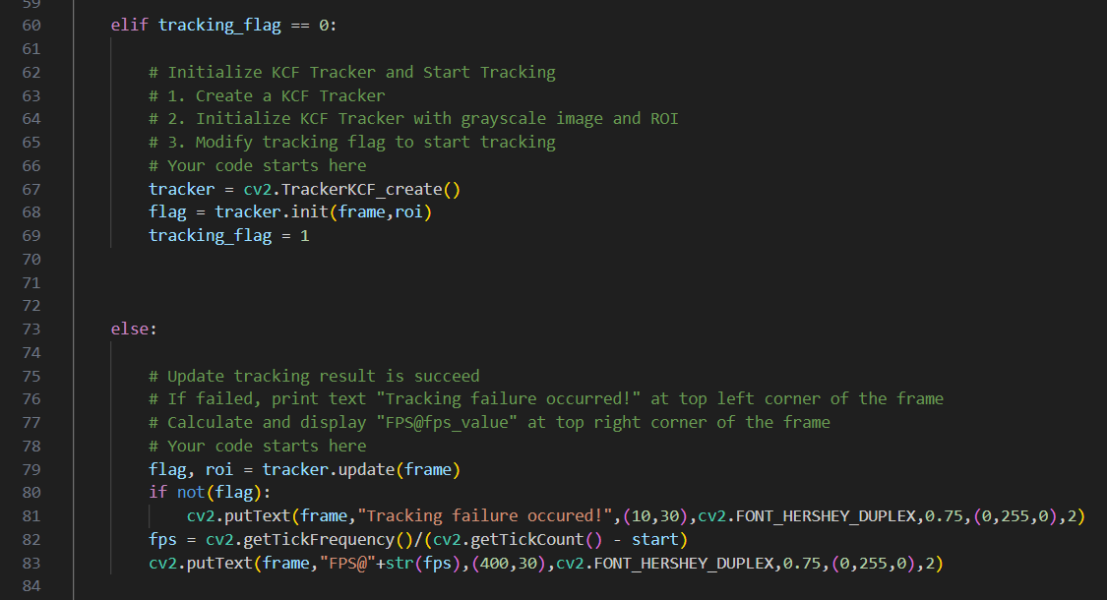

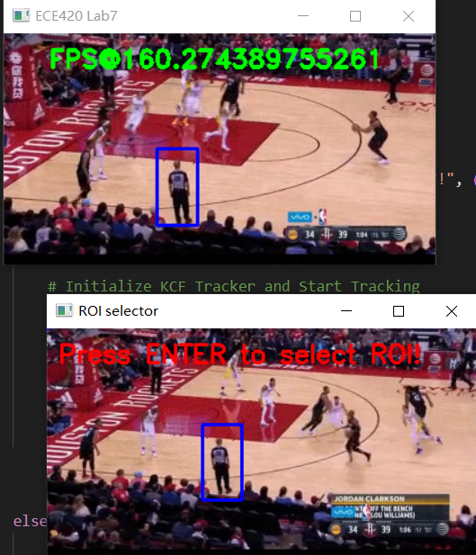

Rectangle around target,

Text “FPS@ +fps” when tracking

tracking

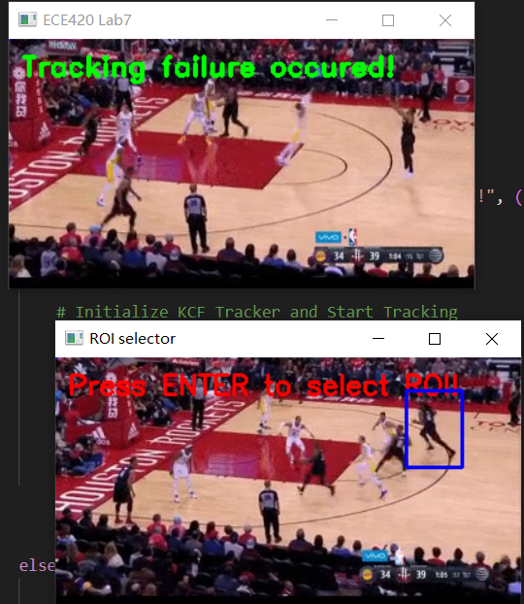

Rectangle around the target

Text “Tracking Failure occurred!” when object is missing